AL KHOZAMA INTERNATIONAL SCHOOL, DAMMAM, K.S.A

Affiliated to CBSE – New Delhi, Affiliation No. 57300019
WORKSHEET .2
GRADE: III –EVALUATION I
SUBJECT: Urdu (TL)

س1۔
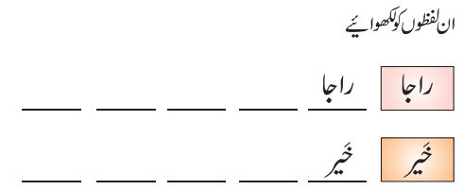
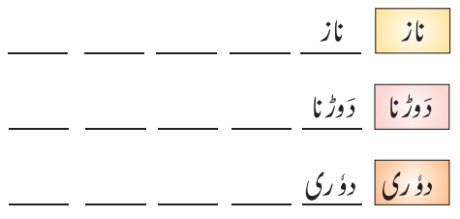

س2۔
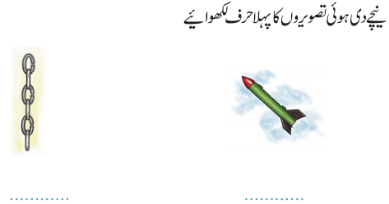
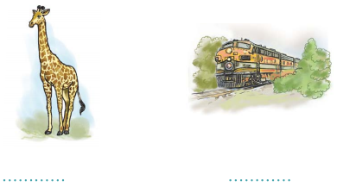

س3۔
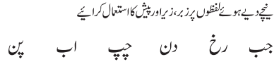

س4۔
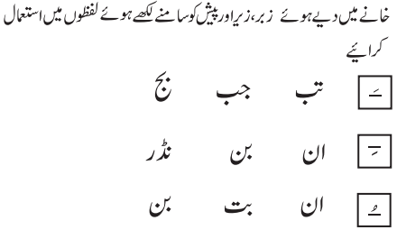

س5۔
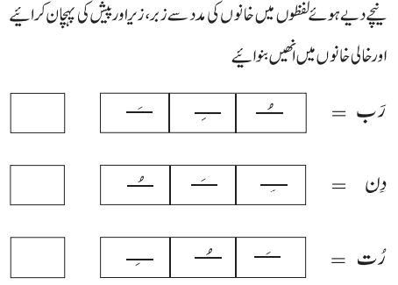

س6۔


