**Al KHOZAMA INTERNATIONAL SCHOOL, DAMMAM**

Affiliated to CBSE – New Delhi **WORK SHEET- II**

**GRADE: I**

**EVALUATION-1 2019-20**

**SUBJECT: EVS**

1. **Choose the correct answer:**
2. Which is a joint family?

A) 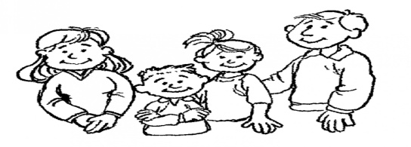 B) 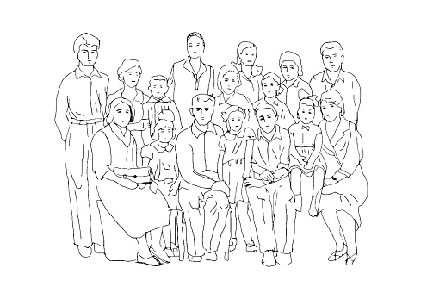

1. How do you feel when you touch a stone?
2. Soft B) Hard 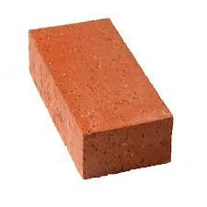
3. Where do we brush our teeth?
4. kitchen 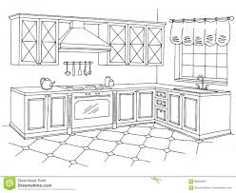 B) Bathroom 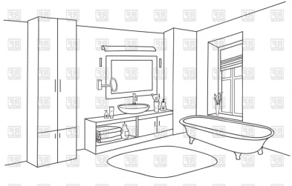
5. The doctor work in a
6. hospital 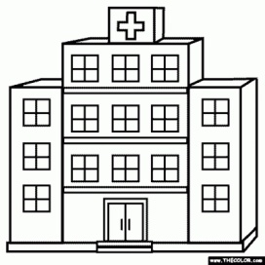 B) police station 
7. Which is an indoor game?
8. 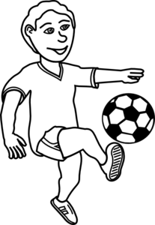 B) 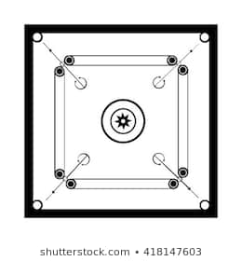
9. **Match the following:**

See 

Feel 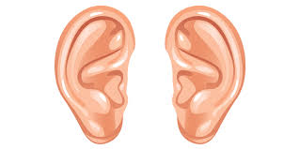

Smell 

Hear 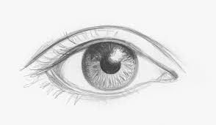

Taste 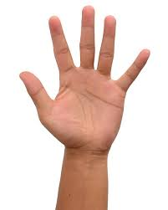

1. **Label the door , roof ,wall and windows of house?**



1. **Answer the following questions:**
2. Write True or False.

A) We taste with our ears ( )  
B) We feel with our hands ( )

1. A)Which game are the children playing?

________________________________

B) Is it a group game?

________________________________

1. Why do we wear clothes?

_____________________________________________________________________

_____________________________________________________________________

1. Draw and name the sense organs that you use while watching TV.

1. **Complete the table**

Vegetable seller , doctor , hospital ,fireman, shop, firestation

|  |  |  |
| --- | --- | --- |
|  | Who are they? | What is their workplace? |
| Fireman firefighter clipart black and white clipartfest |  |  |
| Image result for picture of  vegetable seller clipart black and white |  |  |