
Al KHOZAMA INTERNATIONAL SCHOOL, DAMMAM
Affiliated to CBSE – New Delhi
WORK SHEET- 2
FIRST TERM EXAM, 2019 - 20
GRADE: IV SUBJECT: SOCIAL STUDIES

- Circle the Correct Answer

  - An armed group of people who fight for the country using aircrafts. (Army Air force Navy Electrician)
  - __________________is an outdoor game
(Chess, Ludo, Carom, Football)
  - Every Indian enjoys some rights, they are our ________________rights
(Fundamental Duties, Fundamental Rights, Constitution, Elements)
  - Capital of Punjab__________________________.
(Chandigarh, Port Blair, Bhopal, Panaji)
  - Crafts people, like potters and weavers usually learn their work from ____________________________
(University, College, Elders at home, School)
  - The stone pillar is found in Sarnath in ________________________________. (Uttar Pradesh Tamil Nadu Chennai Kerala)

Fill in the blanks

  - India is located in __________________________

  - Northern rivers are mainly_______________________
  - _______________are the things we are free to do

  - _______________is a place where people sell things like toys, crafts and clothes

  - India has _______________ states

  - We must follow ___________________ in a game

Match the Following

  - Doctor – Meghalaya

  - Gujarat - Acrobats

  - Mawsynram – Boxing

  - Mary Kom – Gandhi nagar

  - Circus – Bankim Chandra Chatterjee

  - Vande Mataram – Stethoscope

- Write True or False

  - The Lion Pillar has two lions standing back to back. ------------------------

  - We must protect Wildlife and Environment. ------------------------

3. A weaver makes Clay Pots ------------------------

- Every child must be given medical care ------------------------

- It is not important for Children to eat healthy food. ------------------------

Name the following

  - The person who makes wooden furniture and shelves

--------------------------------------------------------------------------------------------
  - Hot and dry winds

--------------------------------------------------------------------------------------------
  - National song of India

--------------------------------------------------------------------------------------------
  - National Capital Territory of India

--------------------------------------------------------------------------------------------
- Identify the Picture and Write about two or three sentences each
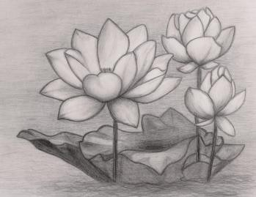
1.
------------------------------------------------------------
----------------------------------------------------------------
----------------------------------------------------------------
----------------------------------------------------------------
----------------------------------------------------------------

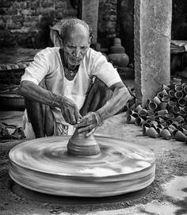
2. ------------------------------------------------------------
----------------------------------------------------------------
----------------------------------------------------------------
----------------------------------------------------------------
----------------------------------------------------------------
-----------------------------------------------------------------
--------------------------------------------------------------------------------------------

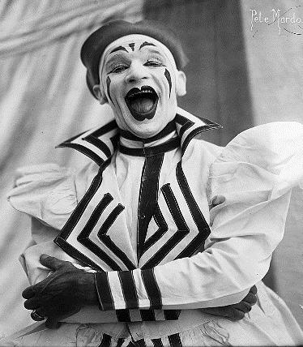
3. ------------------------------------------------------------
----------------------------------------------------------------
----------------------------------------------------------------
----------------------------------------------------------------
----------------------------------------------------------------
-----------------------------------------------------------------
--------------------------------------------------------------------------------------------

Answer the Following Questions in two or three sentences

Explain three seasons of India:

--------------------------------------------------------------------------------------------
--------------------------------------------------------------------------------------------
--------------------------------------------------------------------------------------------
--------------------------------------------------------------------------------------------
--------------------------------------------------------------------------------------------
--------------------------------------------------------------------------------------------

  - What is our National Anthem? When do we sing it?

--------------------------------------------------------------------------------------------
--------------------------------------------------------------------------------------------
--------------------------------------------------------------------------------------------
--------------------------------------------------------------------------------------------
--------------------------------------------------------------------------------------------
--------------------------------------------------------------------------------------------

  - What would happen if we did not have Tailors and Cobblers?

--------------------------------------------------------------------------------------------
--------------------------------------------------------------------------------------------
--------------------------------------------------------------------------------------------
--------------------------------------------------------------------------------------------
--------------------------------------------------------------------------------------------
--------------------------------------------------------------------------------------------

  - Write about 2-3 Duties that you do at home.

--------------------------------------------------------------------------------------------
--------------------------------------------------------------------------------------------
--------------------------------------------------------------------------------------------
--------------------------------------------------------------------------------------------
--------------------------------------------------------------------------------------------
--------------------------------------------------------------------------------------------

- Answer the following questions in four or five sentences

  - Describe 4 Fundamental Duties that you think are the most important.

------------------------------------------------------------------------------------------------
------------------------------------------------------------------------------------------------
------------------------------------------------------------------------------------------------
------------------------------------------------------------------------------------------------
------------------------------------------------------------------------------------------------
------------------------------------------------------------------------------------------------
------------------------------------------------------------------------------------------------
------------------------------------------------------------------------------------------------
------------------------------------------------------------------------------------------------

  - What would you see in a Circus?

------------------------------------------------------------------------------------------------
------------------------------------------------------------------------------------------------
------------------------------------------------------------------------------------------------
------------------------------------------------------------------------------------------------
------------------------------------------------------------------------------------------------
------------------------------------------------------------------------------------------------
------------------------------------------------------------------------------------------------
------------------------------------------------------------------------------------------------
------------------------------------------------------------------------------------------------

  - Locate the following states in the map.
    - Tamil Nadu
    - Kerala
    - Jammu & Kashmir
