**AL KHOZAMA INTERNATIONAL SCHOOL, DAMMAM, K.S.A**

**Affiliated to CBSE – New Delhi, Affiliation No. 57300019**

**WORKSHEET-1**

**GRADE: 1 – FIRST TERM EXAMINATION /EVALUATION I**

**SUBJECT: MATH**

Q1. Write the number pairs that is missing in the number pair of 8.

A. 5, ____ B. 1,_____

Q2. Draw the spots on each wing to show different number pairs of 6.

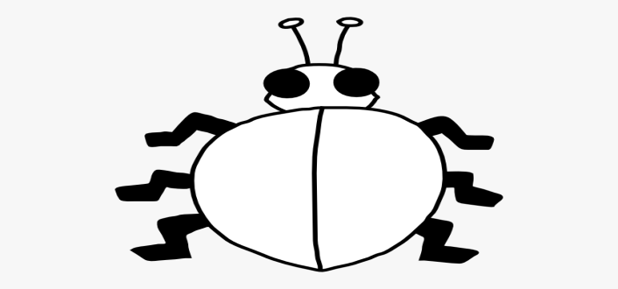

Q3. How many tens and extras in each number?

A. 13 _____ ten and _____ extras

B. 7 ______ ten and _____ extras.

C. 20 _____ ten and _____ extras.

Q4. Write the number names.

A. 12 __________ B. 14____________ C. 30____________ D. 20__________

Q5. Find the tens and ones in the picture.



There are ____ tens ____ ones.

Q6. Circle the things. Which is bigger?

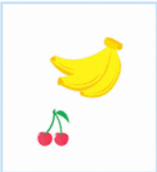

Q7. Write more for the name with more letters and less for the name with less letters.

|  |  |  |  |  |  |
| --- | --- | --- | --- | --- | --- |
| M | U | M | B | A | I |
| S | A | U | D | I |  |

Q8. Which name is bigger? Why?

**R A H U L**

Rameshsingh

________________________________________________________.

Q9. Write the addition sentences using + and =.

A. 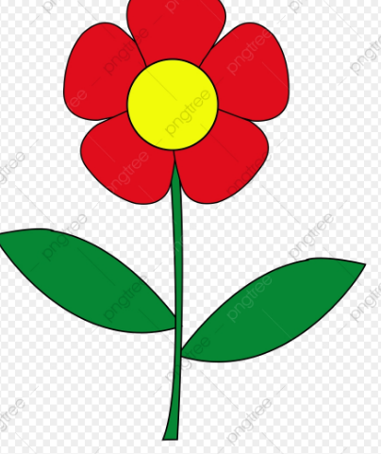 +  = 

_________ _______ _______

B. Fiza has 8 balloons. She gets 2 more balloons from her mother. How many balloons does she have in all?

_________ ________ ________

Q10. Add.

A. 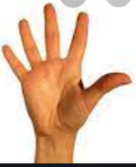+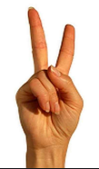=

B.  +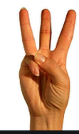 =

C. 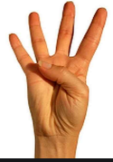+ =

Q11. Write story sum for 6+2.

______________________________________________________________________________________________________________________________________

Q12. Add the numbers side by side and up and down.

A. 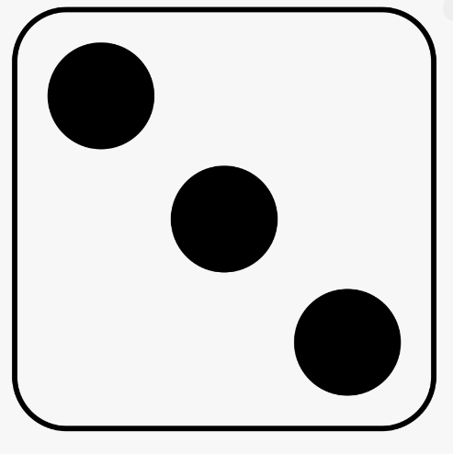 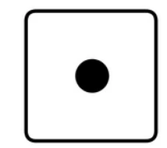

_______ + _____=______

B.

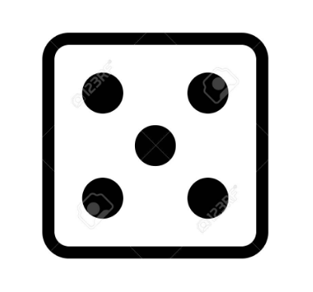 +

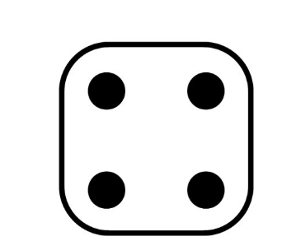

Q13. Draw your own picture to show the addition.

7+2=9

Q14. Flip the number pairs.

A. 8,1 ________ B. 9,0 ________ C. 2,6 __________