AL KHOZAMA INTERNATIONAL SCHOOL,DAMMAM

Affiliated to CBSE – New Delhi, No:5730019

EVS WORKSHEET-1 (Block 7)

- Fill in the blanks
- _______________ covers the entire body.

- ________________ helps us to know the taste of a food item.

- Chocolates are _____________ in taste.

- We can smell with our _______________.

- The sense organ that helps us to know when a mosquito bites us _________________.

- The sense organs that are used to watch television are _____________ and _______________________

- True or false

- We cannot touch and feel with our skin-

- Eyes help us to read books –

- Lemon juice is sour in taste-

- We hear with our ear-

- Match the following:

- 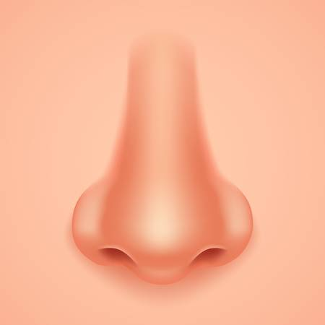 |  | See
-  |  | Smell
- 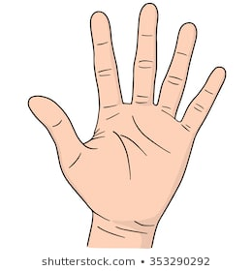 |  | Taste
- 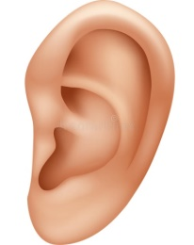 |  | Feel
-  |  | Hear

