** AL KHOZAMA INTERNATIONAL SCHOOL, DAMMAM**

Affiliated to CBSE – New Delhi- Affiliation Number - 5730019

**EVALUATION –I (2021–‘22)**

**Subject:English Worksheet-1**

Date: /05/2021 Class: 1

**Part – A**

**Section – A**

1. **Read the passage and answer the following questions.**

**The Ant and the Grasshopper**

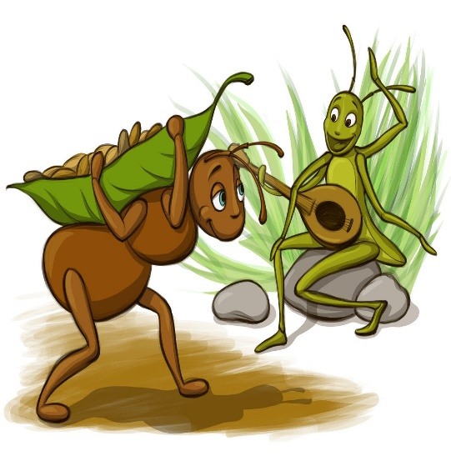

In a field one summer’s day a Grasshopper was hopping and singing. An Ant passed by, bearing along with great tall an ear of corn. “Why not come and chat with me,” said the Grasshopper. “I am helping to lay up food for the winter,” said the Ant. “Why bother about winter?” said the Grasshopper. But the Ant went on it’s way and continued its toil. When the winter came the Grasshopper had no food and found itself dying of hunger while it saw the ants distributing every day corn and grain from the stores they had collected in the summer. Then the Grasshopper knew. It is best to prepare for the days of need.

Select the correct answer.

1. What was Grasshopper doing? _________
2. Crawling and dancing
3. Sleeping and snoring
4. Hopping and singing
5. “Why not come and chat with me” Who said that? _______________.
6. Ant
7. Grasshopper
8. Dog
9. Who worked hard and stored the food? _______________.
10. Ant
11. Grasshopper
12. Cat
13. What did Ant distribute in the winter season? _______________.
14. Corn and grains
15. Choclates and ice creams
16. Fruits and vegetables
17. It is best to prepare for days of ________ .
18. Happiness
19. Need
20. Dissappointment

**Section – B**

**Grammar**

1. Make at least four new words with the help of letters given below.

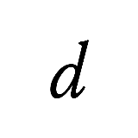

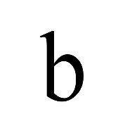

1. __________
2. __________
3. __________
4. __________
5. Write the sentence in correct order.
6. the cot./She is/sitting on

_________________________

1. is/He/talking.

_________________________

1. jumping./Keechu’s brother/was

_________________________

1. dancing./He/is

_________________________

1. Write two doing words with the same vowel sound as ‘Bun’.

______________________________________

1. Write 1 words that rhyme with the word ‘Hot’ and ‘fat’

_____________________________________

**Part - B**

**Section – C**

**(Creative Writing)**

1. Write the sentence again with capital letter and full stop.
2. the small birds were singing softly

____________________________

1. the farmer had a good crop

____________________________

1. Write the correct sequence for the below.



1. Keechu gets wet.
2. Keechu monkey can’t sleep.
3. Keechu sleeps by the river.
4. Keechu goes out.

1. Fill in the blank space with the correct rhyming word from the help box.

|  |
| --- |
| **caught,school, fins, ocean, fish, free, flap** |

How I wish

I were a _________!

My day would begin

Flapping my fins.

I’d make a commotion

Out in the ocean.

It would be cool

To swim in a _________.

In the sea,

I would move so _________.

With just one thought,

Don’t get _________

**Section – D**

**(Literature)**

1. Write true or false.
2. Keechu goes out into the forest. _______________
3. Keechu’s sister was jumping. _____________
4. Keechu rolls into the water. ______________
5. Keechu is a cat. _____________
6. Why can’t Keechu monkey sleep?

|  |
| --- |
|  |
|  |