AL KHOZAMA INTERNATIONAL SCHOOL, DAMMAM, K.S.A

Affiliated to CBSE – New Delhi, Affiliation No. 57300019
WORKSHEET.1
GRADE: III–EVALUATION I
SUBJECT:URDU (TL)

س۔1

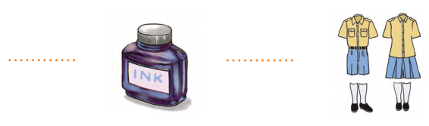
س2۔


س3۔
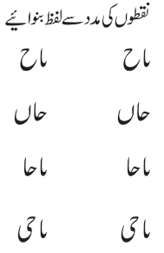
س4۔
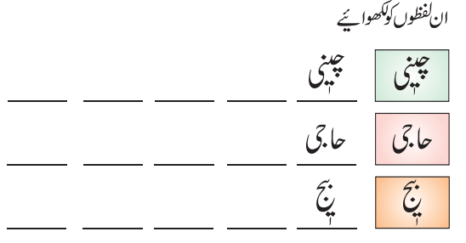

س5۔


