**AL-KHOZAMA INTERNATIONAL SCHOOL-DAMMAM**

 **B.E.S.T. Group of Schools, K.S.A.**

Affiliated to CBSE – New Delhi, Affiliation No: 5730019

**REVISION WORKSHEET-2-EVALUATION-1 (2021-22)**

**Subject: Science**

Date: 10 /06/2021 Time Allowed: 1 Hour, 30 minutes

Class: IV Sec: _____

**PART-2**

**V Answer the following questions in 1 to 2 sentences:**

21**.** What do plants need to make their food?

22. How does the coconut tree survive in strong winds?

23. What are nocturnal insects? Give some examples

24. Define metamorphosis. Name any two insects that undergo metamorphosis

25. Ramu slept in a forest at night. What would be the difficulties that he may face at night?

**VI.** **Identify the pictures and write two sentences about each:**

26. 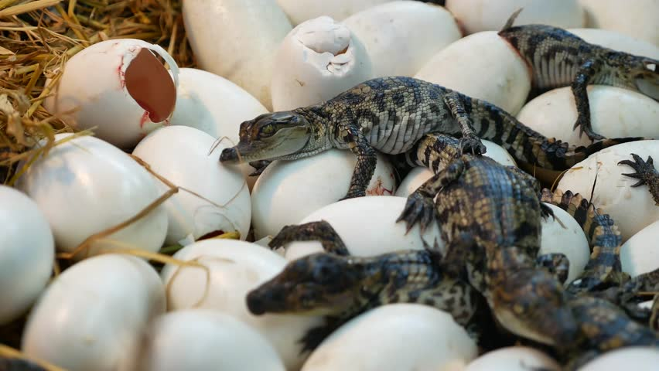

27. 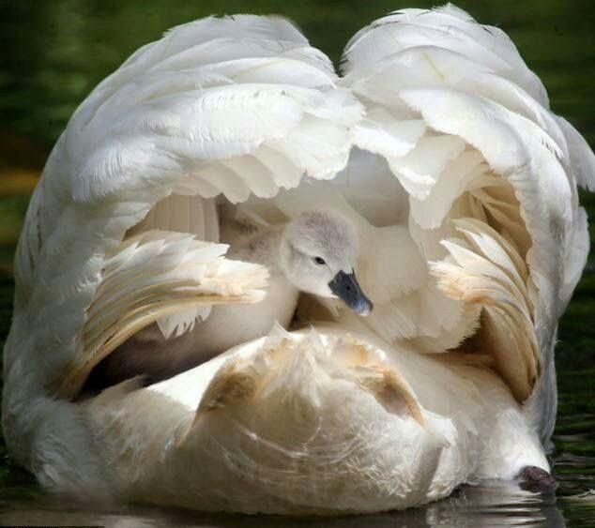

28. 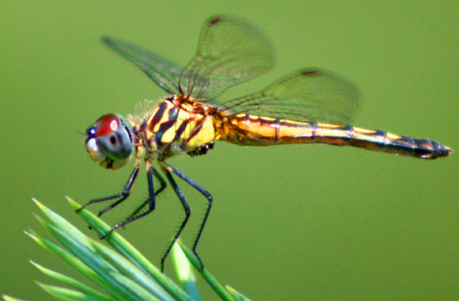

29. 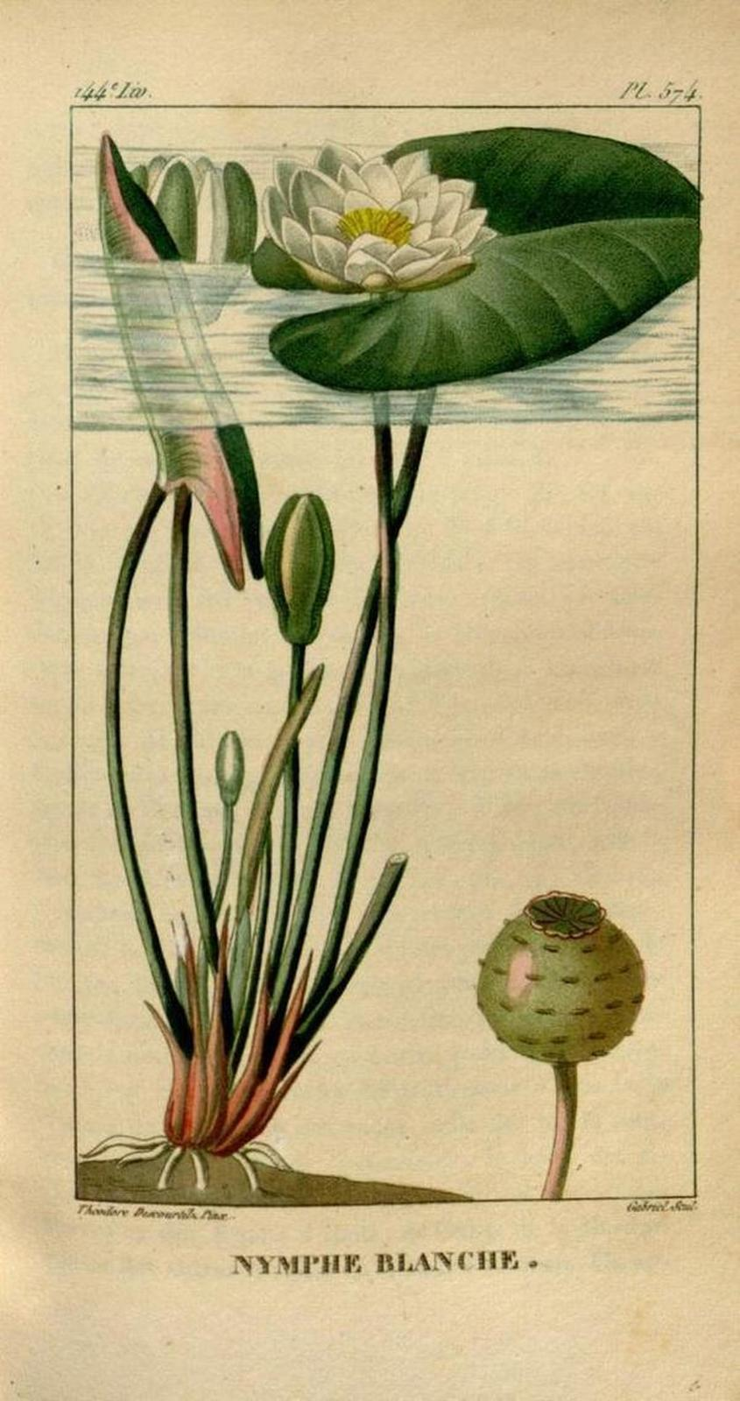

30 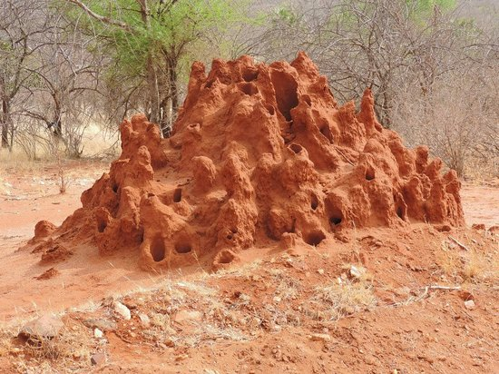

**VII. Answer the following questions (31 to 36) in 3 to 4 sentences:**

31. Explain the process of photosynthesis with the help of a neat labelled diagram.

32. Describe Life Cycle. Briefly explain the life cycle of a frog.

33. Compare the plants those grow in deserts and mountains?

34. Describe an experiment to show, that plants need sunlight.

36. How can killing of dragonflies be harmful to us?

37. Label different stages in the life cycle of a duck.

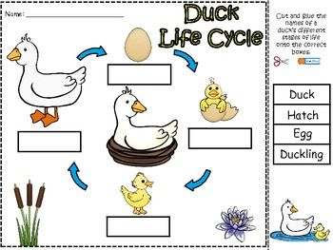

38. Complete the table.

|  |  |  |
| --- | --- | --- |
| **S.NO.** | **NAME OF INSECTS** | **FOOD THEY EAT** |
| **1** | **Bed bugs and fleas** |  |
| **2** | **Dragonflies** |  |
| **3** | **Moths** |  |
| **4** | **Silverfish** |  |

38. Label the different body parts of an insect.

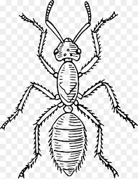

39. Mark the different stages in the life cycle of a frog.

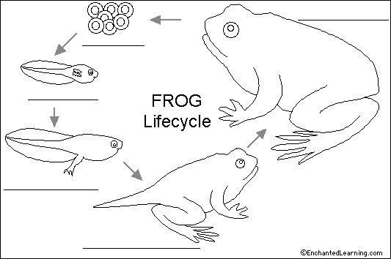

40. Study the two images shown given below. Which plants in the images will grow well? Comment.

IMAGE- A IMAGE -B

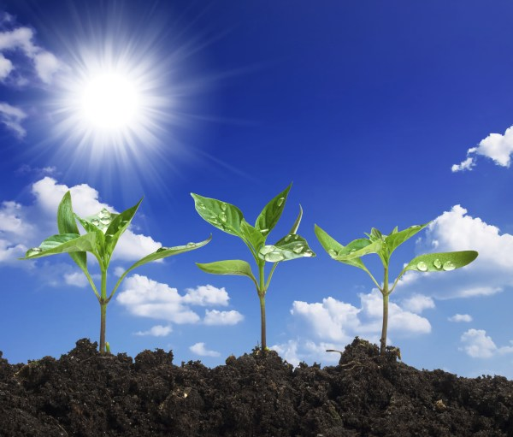 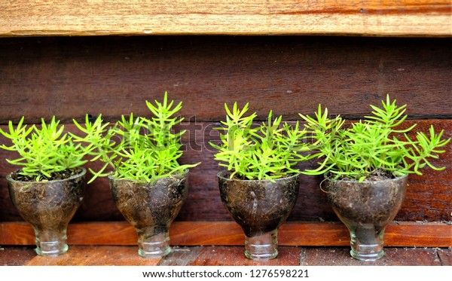

41. Compare the life cycle of a frog and an ant.**ar.NO.**

|  |  |  |
| --- | --- | --- |
| **S.NO.** | **SIMILARITIES** | **DIFFERENCES** |
| 1 |  |  |
| 2 |  |  |
| 3 |  |  |