**Al KHOZAMA INTERNATIONAL SCHOOL, DAMMAM, K.S.A**

Affiliated to CBSE – New Delhi.

**Work sheet-2**

**EVALUATION-1/ FIRST EXAM, 2019-20**

**Subject: Science**

**GRADE: V**

1. Identify the actions as ***Push*** or ***Pull.***  
   i) Lifting a bucket of water: ___________

ii) Kicking a football: __________

iii) Pushing a desk along the floor: __________

1. State whether the force applied is changing the ***shape*** or the ***motion*** of the object.

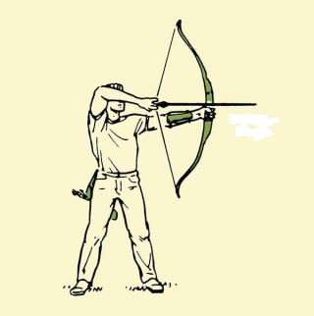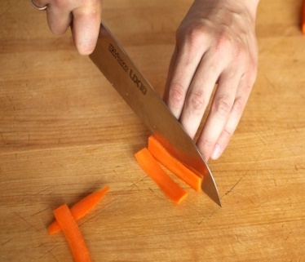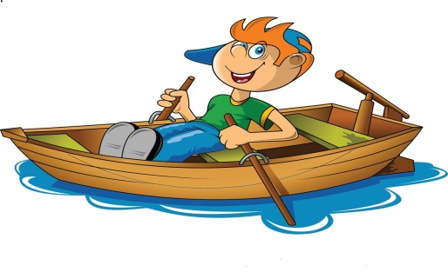

______________ _________________ ________________

1. Why does a ball throw up in the air falls on the ground?

_______________________________________________________________________________________________________________________________________________________________________________________________________________

1. Put a tick on the picture where you think work is being done. Put a cross on those where you think no work is being done? Give reasons.

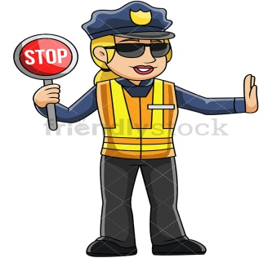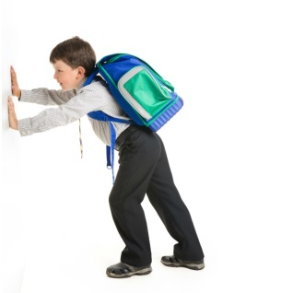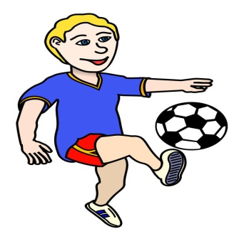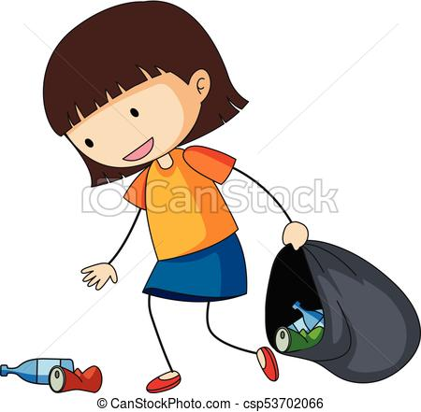

A B C D

A:____________________________________________________________________B:____________________________________________________________________C:____________________________________________________________________

D:____________________________________________________________________

1. Force is applied to break a stick. What change is force causing in the stick?

__________________________________________________________________________________________________________________________________________

1. What are some ways to reduce friction?

_______________________________________________________________________________________________________________________________________________________________________________________________________________

1. How does the property of water, being a universal solvent help us in:

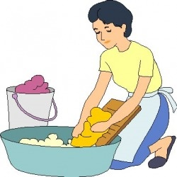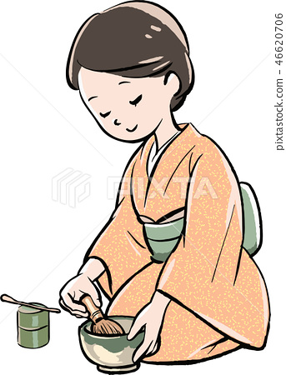

Washing clothes Making Tea

_______________________________________________________________________________________________________________________________________________________________________________________________________________

1. Carbon dioxide dissolves easily in water. How is it useful for us?

__________________________________________________________________________________________________________________________________________

1. Identify the force in the picture.

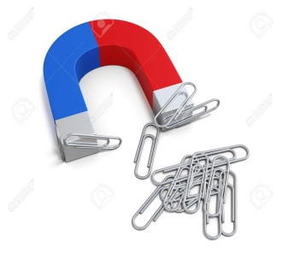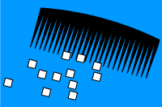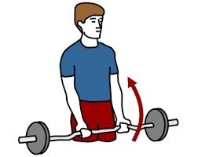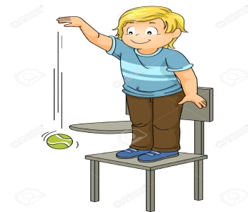  
______________ __________________ __________________ ________________

1. How does the friction help the following activities?  
   i) Car to stop: __________________________________________________________

ii) Luggage to roll: ______________________________________________________

iii) Carrom coin to slide: __________________________________________________

1. How does the shape of the fish help them to swim?

__________________________________________________________________________________________________________________________________________

1. How does the force of friction change with increase in:

A: Area in contact: ______________________________________________________

Mass of object: ________________________________________________________

1. Water is rarely found in pure form. Why?

_____________________________________________________________________

_____________________________________________________________________

1. Why are water storage tanks that supply water to colonies made at a height?

__________________________________________________________________________________________________________________________________________

_____________________________________________________________________

1. How can we change the shape of an object? Write three examples.

_______________________________________________________________________________________________________________________________________________________________________________________________________________

1. Why do traffic police control the speed of the vehicles during rain?

_______________________________________________________________________________________________________________________________________________________________________________________________________________

1. The horses are pulling a sphere in two directions. When will the horses not be able to move the sphere in their direction?

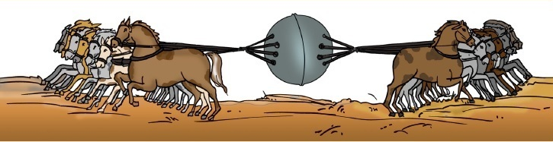

_______________________________________________________________________________________________________________________________________________________________________________________________________________

1. How is the force of friction different from magnetic force?

__________________________________________________________________________________________________________________________________________

1. Why does a big ship, made of iron, float on water but a coin sinks?

_______________________________________________________________________________________________________________________________________________________________________________________________________________

1. Where will the force of water be more? Why?





