**Al KHOZAMA INTERNATIONAL SCHOOL, DAMMAM ,K.S.A**



Affiliated to CBSE – New Delhi **WORK SHEET-2**

**GRADE: 4**

**EVALUATION-1, 2019-20**

**SUBJECT: SCIENCE**

**Block 6-More about insects,Block6-Life cycle of animals**

**I.Fill in the blanks**

1. Fleas are found on ________________________________.
2. Silver fish eat ______________and paste used to bind books.
3. An ant family is called an ___________________________________.
4. A larvae ant spins a cocoon around itself which is called __________________________
5. The transformation of a caterpillar into a butterfly is called ____________________________.
6. The young one of a frog__________________________________________________.
7. Young animal in the very early stages of development before birth is called ________________.
8. A protective case spun by larva is known as ____________.
9. ______________ant lays eggs.
10. Sweet liquid inside flowers is _________________.
11. A baby bird is called a _____________________.
12. The third stage of bird is______________________.
13. Caterpillars eat ______________________.
14. The baby of an elephant is called ___________________.
15. A young animal in the very early stages of development before birth _____________.

**II.Label and explain the stages**

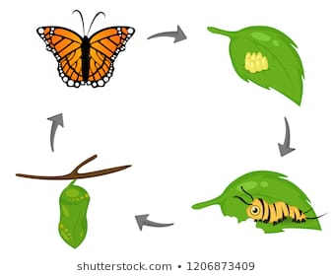

**________________________________________________________________________________________________________________________________________________________________________________________________________________________________________________________________________________________________________________________________________________________________________________________________________________________________________________________________________________________________________________________________________________________________________________________________________________________**

**III. Identify the animal and comment on it**

1

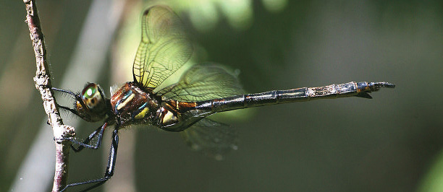

____________________________________________________________________________________________________________________________________________________________________________________

**2.**

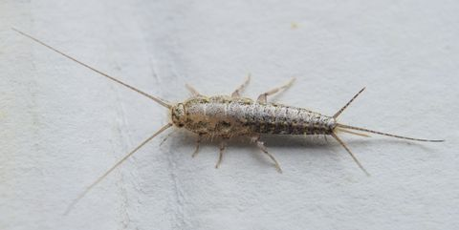

_________________________________________________________________________________________

_________________________________________________________________________________________

______________________________________________________________________________________________

3.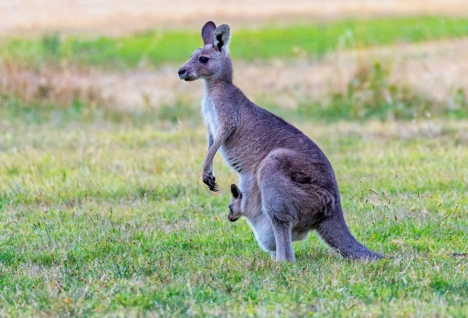

**IV.Answer the following questions in three or four sentences each.**

1. Draw the life cycle of an ant.

2.How an ant hill can be compared to our home?

3.Farmers spray insecticides to kill insects like moth which damage crops. How this can be harmful to us?

4.Caterpillars have many body parts .Are caterpillars insects? Justify your answer.

5. Why is the process of transformation of a tadpole into a frog called metamorphosis?

______________________________________________________________________________________________________________________________________________________________________________________________________________________________________________________________________________________________________________________________________________________________

6. Do you think butterflies are similar to frogs or birds in the way they raise their young ones?

________________________________________________________________________________________________________________________________________________________________________________________________________________________________________________________________________________________

7.

