AL KHOZAMA INTERNATIONAL SCHOOL, DAMMAM

Affiliated to CBSE – New Delhi.

Work sheet-1
FIRST TERM EXAM, 2019-20
Subject: Social Science
GRADE: VII
- Unscramble the words and fill in the blanks.
i)The empire was divided into ______________ QITA
ii) The sultan appointed his bandagans as ________________ QATADRAIS
iii) The bandagans were the special ________________ of the sultan. LEVSAS
iv) The sultan asked the Iqtadars to maintain ___________ OLDSEIRS
- Which do you think is more important to strengthen a kingdom-agriculture or army? Give reasons for your answer.
______________________________________________________________________________________________________________________________________________________________________________________________________________________________________________________________________________________________________________________________________________________________________________________________________________________________________________________________________________
- Look at the picture of the coins carefully and answer the questions.

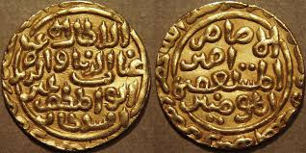

- Write any two bits of information that this source gives us about the Delhi Sultanate.
________________________________________________________________________
________________________________________________________________________
- What information does it NOT give us about it ?

4. Write two differences between intrusive igneous rocks and Extrusive igneous rocks.
________________________________________________________________________________________________________________________________________________________________________________________________________________________

5. Answer the following questions about the igneous rocks
A. Label the volcano, the magma, the lava and the igneous rock in the image.
B. Explain the term igneous rocks and their formation.

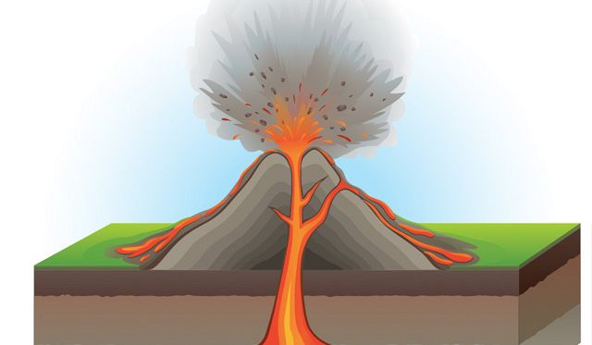

_____________________________________________________________________________
____________________________________________________________________________________________________________________________________________________________________________________________________________________________________________________________________________________________________________________

6. When do you think regional party becomes more powerful and national parties?
____________________________________________________________________________________________________________________________________________________________________________________________________________________________________________________________________________________________________________________

7. Draw a simple diagram to explain the rock cycle.

8. Label the different layers of the Earth and explain it.

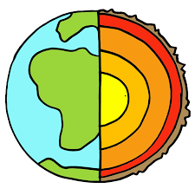
___________________________________________________________________________________________________________________________________________________________________________________________________________________________________________________________________________________________________________________________________________________________________________________________________________________________________________________________________________________________________________________________________________________________________________________________________________
9. The rock cycle is never – ending it has no beginning and no end. Explain
______________________________________________________________________________________________________________________________________________________________________________________________________________________________________________________________________________________________________________________________________________________________________________________________
10. Classify the following words under two headings in 2 columns- democratic government and authoritarian government .
Collective decisions, one – person rule, elections, dictator, elected representative, unlimited power, military rule, vote
Authoritarian government | Democratic government

11. Arcadia had a democratic government. Write 3 democratic features that would be practice
by the government of Arcadia .
_______________________________________________________________________________________________________________________________________________________________________________________________________________________________________
12. Where can a coalition government be formed and why?
______________________________________________________________________________________________________________________________________________________________________________________________________________________________________________________________________________________________________________________________________________________________________________________________________________________________________________________________________________
13. Explain the structure of the atmosphere. Support your explanation with a simple
diagram.

_________________________________________________________________________________________________________________________________________________________________________________________________________________________________________________________________________________________________________________________________________________________________________________________________
14. Explain why we feel sticky and uncomfortable on humid days.
_________________________________________________________________________________________________________________________________________________________________________________________________________________________________________________________________________________________________________________________________________________________________________________________________
15. Should history be divided into periods? Give reasons to support your answer.
____________________________________________________________________________________________________________________________________________________________________________________________________________________________________________________________________________________________________________________

