AL KHOZAMA INTERNATIONAL SCHOOL, DAMMAM

Affiliated to CBSE – New Delhi.

Work sheet-2
FIRST TERM EXAM, 2019-20
Subject: Social Science
GRADE: VIII
- In the 18th century _______________farming had become a common form of revenue collection.
- The revenue was generally collected by the ______________or ________________.
- Fresh water is available on earth for use only ____________per cent.
- Fresh water in usable form is not stored in _________________state. It is in liquid form.
- The Zamindar collected the revenue from the mahals ( True/ False)
- The Ryotwari system introduced in North India. ( True/ False)
- Water distribution is unequal in India because India a hot climate. ( True/ False)
- The British wanted the farmers in Bengal to grow these crops. __________________
- An agreement signed between the planter and Ryot. _________________________
- A food crop in Bengal that had declining production due to indigo cultivation.
________________________
- The bar graph shows the number of religious communities in a state. Read it and answer the questions.
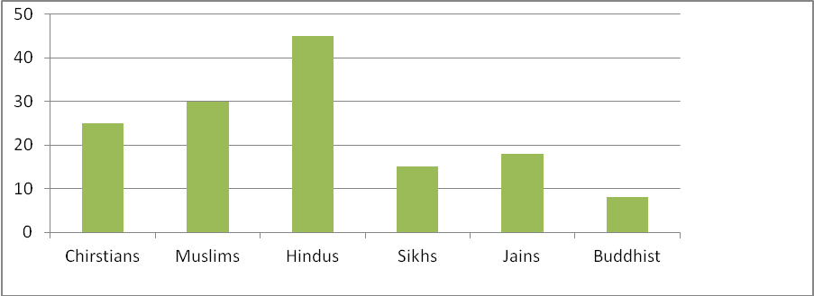
i) The state government decided that schools, collages and offices will be closed only on
all Hindu festivals. Do you think this is right? Give reason yur answer.
________________________________________________________________________
________________________________________________________________________
________________________________________________________________________
ii) Write one way in which the Indian constitution make sure that the rights of minorities
are protected : __________________________________________________________.
- How does the Indian Constitution check the misuse of power by leaders or government?
________________________________________________________________________________________________________________________________________________________________________________________________________________________
- Mausynram is the wettest place on earth. Does this mean that it will never face water scarcity? Why or why not?
_______________________________________________________________________________________________________________________________________________________________________________________________________________________
- In a district of Idukki and Palakkad in Kerala, people had faced both floods and droughts in the year of 2012. Give a solution to handle water scarcity and excess water in the districts.
________________________________________________________________________________________________________________________________________________________________________________________________________________________
- How do the following methods of irrigation help us to reduce the use of water? 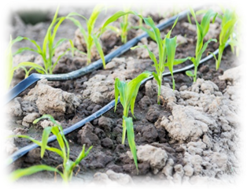 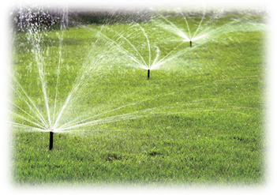
Drip irrigation Sprinkler irrigation
________________________________________________________________________________________________________________________________________________
________________________________________________________________________
- Why do you think indigo cultivation caused discontent among the rural society of Bengal?
________________________________________________________________________________________________________________________________________________________________________________________________________________________
- How was the indigo cultivation responsible for the breakdown of traditional farming system in India?
_______________________________________________________________________
________________________________________________________________________________________________________________________________________________
- Write one rule each of a monarchial government and democratic government.
Monarchy | Democracy

- Explain two reasons for water scarcity in each of the following.
A: In rural areas ________________________________________________________________________________________________________________________________________________
B: In Urban areas
________________________________________________________________________________________________________________________________________________
- Make your own diagram to explain how much fresh water is available on earth for human consumption.
________________________________________________________________________________________________________________________________________________________________________________________________________________________

