
AL KHOZAMA INTERNATIONAL SCHOOL DAMMAM,K.S.A

Worksheets II for Evaluation – I

Subject: Social Science Class: III Blocks:6 and 9

Fill in the blanks:

- A saree is a long single piece of unstitched cloth worn by_____ in India.
2. People wear _____________ types of clothes all over India.

3. ___________ colours stay the same even after being washed.

4. We make different ______________ on clothes to make them look beautiful.

State whether true or false

- Early humans used to wear unstitched clothes.
- Fire station is an important place in a neighborhood.
- We go to the school when we fall sick.
- In north India women wear salwar Kameez.
- People wear different kinds of clothes in different regions.
- Post office is a place where we can keep our money safe.

Name the following:

- Sending and receiving letters.
- Help us when there is fire. _
- Where we go for treatment when we fall sick.
- In north India men wear
- A long-unstitched cloth wore by women.

Match the following

Hospital | Place where we can keep our money safe
Post office | Place where we go when we are very sick
Fire station | Place where we can send or receive letters
Bank | Place that stores firefighting things

Write answer in 2or 3 sentences :

- What do firefighters do? What do they use to put out fires?

______________________________________________________________________________________________________________________________________________________________________________________________________

2. What is a fire station?

______________________________________________________________________________________________________________________________________________________________________________________________________

3. Who work at hospital?

______________________________________________________________________________________________________________________________________________________________________________________________________

4. Why do put stamp on letters?

______________________________________________________________________________________________________________________________________________________________________________________________________

- What is a bank? Why banks are important for us?
____________________________________________________________________________________________________________________________________________________________________________________

Answer the following in 2-3 sentences:

- What is the difference between a stitched and unstitched cloth?
______________________________________________________________________________________________________________________________________________________________________________

- What are the different clothes worn by men in India?
______________________________________________________________________________________________________________________________________________________________________________

- What are the different clothes worn by women in India?
_____________________________________________________________________________________________________________________________________________________________________________

- What are fast colours? How will we know it the colour of a cloth is fast or not?
______________________________________________________________________________________________________________________________________________________________________________

- Why do we make patterns on clothes?
______________________________________________________________________________________________________________________________________________________________________________

- Why do different clothes have different patterns?
______________________________________________________________________________________________________________________________________________________________________________

- Name the clothes worn by people in India using an unstitching cloth.
_____________________________________________________________________________________________________________________________________________________________________________

- How can we make patterns on clothes?
_______________________________________________________________________________________________________________________________________________________________________________________

- Write about any one way of making patterns on clothes.
______________________________________________________________________________________________________________________________________________________________________________

10.what is dye? Write one way of dying a cloth.
____________________________________________________________________________________________________________________

Draw anyone place that help us

Identify the pictures and write one sentence about each:




2.

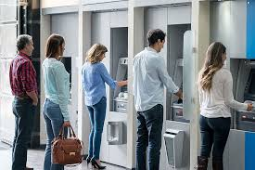

3.
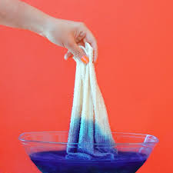
4.
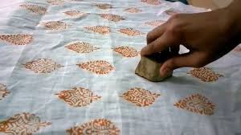

5.
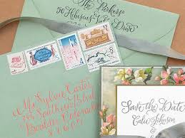

Identify and name the clothes

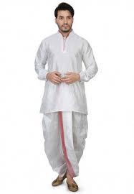

2.
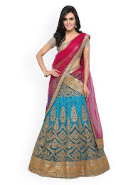

3.
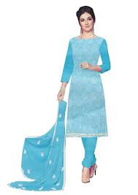
4.

