**Al KHOZAMA INTERNATIONAL SCHOOL, DAMMAM,K.S.A**

Affiliated to CBSE – New Delhi.

**Work sheet-1**

**EVALUATION-1/ FIRST EXAM, 2019-20**

**Subject: Science**

**GRADE: V**

1. Name the organs used for breathing by:

A B C

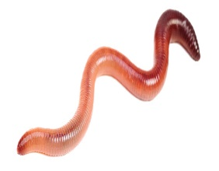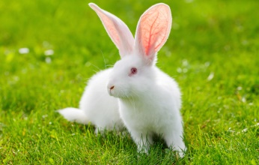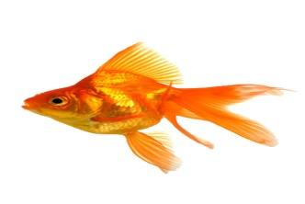

_________________ _________________ ________________

1. What is Echolocation? Which animal use it? How do they use it?

_______________________________________________________________________________________________________________________________________________________________________________________________________________

1. Look at the following diagram. Where will there be more pressure and why?

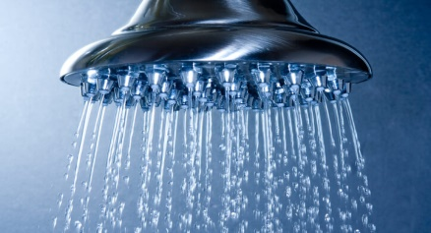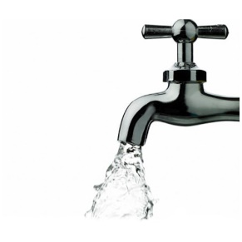

_______________________________________________________________________________________________________________________________________________________________________________________________________________

1. Name five solids and liquids that can dissolve in water.

Solids: _______________________________________________________________

_____________________________________________________________________

Liquids: ______________________________________________________________

_____________________________________________________________________

1. The sense of taste is said to be most developed in humans. How does this super sense help humans survive?

____________________________________________________________________________________________________________________________________________________________________________________________________________________________________________________________________________________

1. Animals found in grass land have body parts that help them run very fast. Why are these animals adapted to run fast?

_______________________________________________________________________________________________________________________________________________________________________________________________________________

1. Describe how the following help the organism to breathe.

|  |  |
| --- | --- |
| C:\Users\LULU\Desktop\download.jpgLungs |  |
| C:\Users\LULU\Desktop\131228-004-CE555626.jpgSpiracles |  |

1. How do whale Breathe?

__________________________________________________________________________________________________________________________________________

1. What type of body covering do fish have?

_____________________________________________________________________

1. Can animals predict natural disasters? Why or why not?

__________________________________________________________________________________________________________________________________________

1. How can snake dance when they can’t hear the sound made by snake charmer?

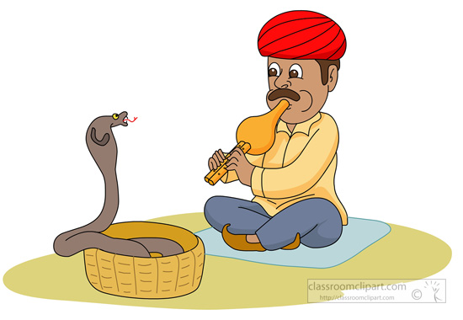

_____________________________________________________________________

_____________________________________________________________________

1. Name an animal which have dry scales in their body

_____________________________________________________________________

1. What can happen if the habitat of an animal is changed?

__________________________________________________________________________________________________________________________________________

1. Name the following:

Animals move from one place to another place: _______________________

Name an animal which can hear infrasound:______________________

1. Look at the following animals. What are the adaptation do they have?

How does it help them to survive in their habitat?

A B

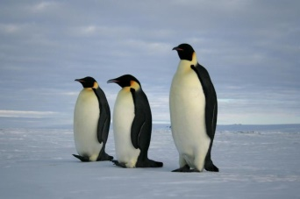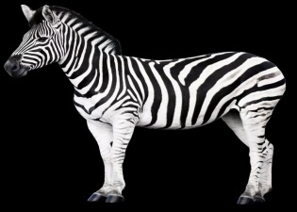

A: ___________________________________________________________________

_____________________________________________________________________B: ___________________________________________________________________

_____________________________________________________________________

1. What is the similarity in the shape of the body of birds and fish? How does it help them?

_______________________________________________________________________________________________________________________________________________________________________________________________________________

1. Dams are made to collect water. Why is the base of the dam broader?

__________________________________________________________________________________________________________________________________________

1. Why water is called universal solvent?

__________________________________________________________________________________________________________________________________________

1. Why did people in the olden days use rivers to transport goods?

__________________________________________________________________________________________________________________________________________

1. Mark the direction of buoyant force in the picture.



