**Al KHOZAMA INTERNATIONAL SCHOOL, DAMMAM,K.S.A**



Affiliated to CBSE – New Delhi **WORK SHEET-1**

**GRADE: III**

**EVALUATION-1, 2019-20**

**SUBJECT: SCIENCE**

**Block 4: Features of birds**

**Block 5: Creepy crawly animals**

**Block 6: Food habits of animals**

**Block 7: Movement in animals.**

**__________________________________________________________________________**

**I.Fill in the blanks**

**1.** __________________ feathers help birds to fly.

2. All birds have bodies covered with _____________

3. Parrot has a ____________ and _______________ beak.

4. _______________ do not build nest.

5. ______________ is the part of insect’s body part which helps to feel or touch.

6. The rear part of the body of an insect is ______________

7. Herbivores have flat and ____________ teeth.

8. _____________ lose their teeth every 8 years.

9. Animals like mole move by making ____________ inside the ground.

10. Tiger run after ________________ to catch and eat them**.**

**II. Identify the picture and comment on it.**

**1.** 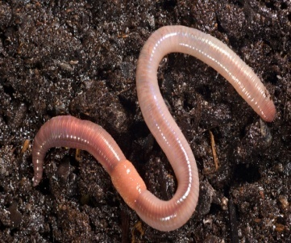

2.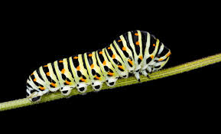

**3.**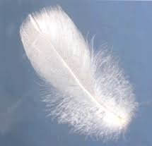

4.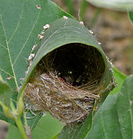

III. STATE TRUE OR FALSE.IF FALSE CORRECT IT

1. Crow’s lay eggs on cuckoo’s nest.

____________________________________________________________________________________________________________________________________________

1. Sparrow has small pointed beak which helps it to help to pick small grains.

____________________________________________________________________________________________________________________________________________

1. Ant sucks nectar from flowers.

____________________________________________________________________________________________________________________________________________

1. Earthworms can replace their lost body parts.

____________________________________________________________________________________________________________________________________________

1. The food chain always starts with animals.

____________________________________________________________________________________________________________________________________________

1. Langurs use their tails to hold branches.

_____________________________________________________________________________________________________________________________________________

**IV. CIRCLE THE ODD ONE OUT AND GIVE REASON**

1. Frog, Duck, Fish

____________________________________________________________________________________________________________________________________________

1. Humans, foxes, goat.

____________________________________________________________________________________________________________________________________________

1. Head, Thorax, crawl

____________________________________________________________________________________________________________________________________________

1. Feather, wings, beak

____________________________________________________________________________________________________________________________________________

**V.ANSWER THE FOLLOWING IN ONE SENTENCE.**

1.What kind of feet do swans have?

2.Name 2 crawling animals.

3.Name the body parts of an insect.

4. Mention the role of antennae.

5. What kind of teeth do sheep have?

______________________________________________________________________________________________________________________________________

VI. ANSWER THE FOLLOWING IN 2 -3 SENTENCES.

1. Cheetahs run after deer. Why?

______________________________________________________________________

2. Langurs do not have claws, so how do they climb trees?

_____________________________________________________________________________________________________________________________________________________________________________________________________________________________________________________________________________________________________________________________________________________________

3. Make a food chain with the following.

Deer, Grass, Bear, Tiger

|  |
| --- |
|  |

4. Omnivores have both pointed and flat teeth. Give reason

______________________________________________________________________________________________________________________________________________________________________________________________________________________________________________________________________________________________________________________________________________________________

5. Why do earthworms come out of the soil when it rains?

____________________________________________________________________________________________________________________________________________________________________________________________________________________________________________________________________________________________________________________________________________________________

6. What to do birds use to build their nest?

____________________________________________________________________________________________________________________________________________________________________________________________________________________________________________________________________________

7. Why do different birds have different kinds of beaks?

_________________________________________________________________________________________________________________________________________________________________________________________________________

8. Label the diagram.

